**JIRA PROJECT BY RASHI**

**

**BA will go to Confluence and create a document there mentioning the description of task in details**

**Click on publish and attach confluence doc link in the BA task description** 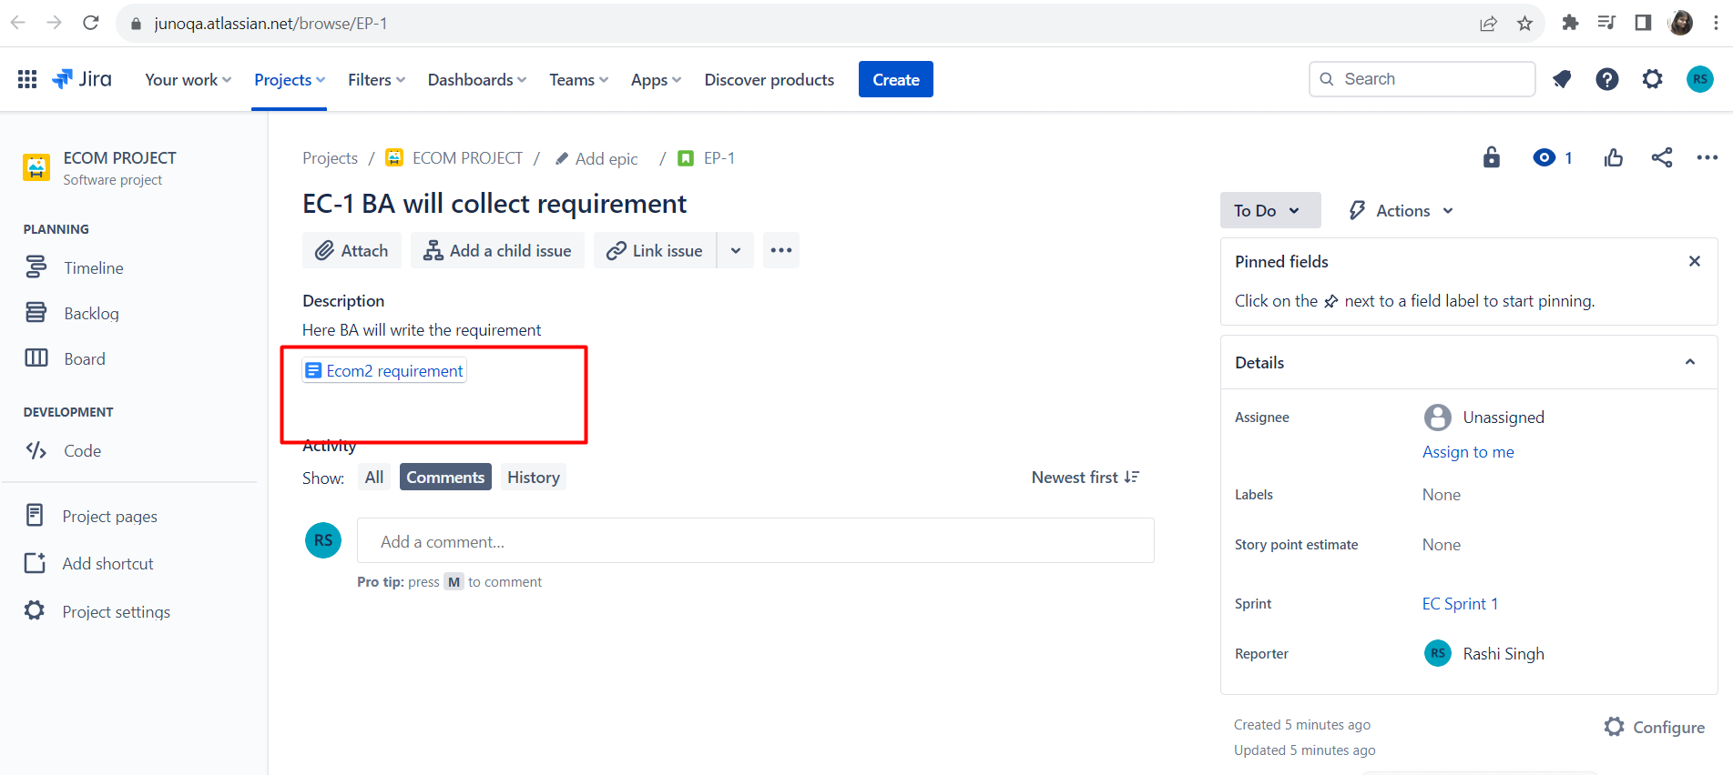

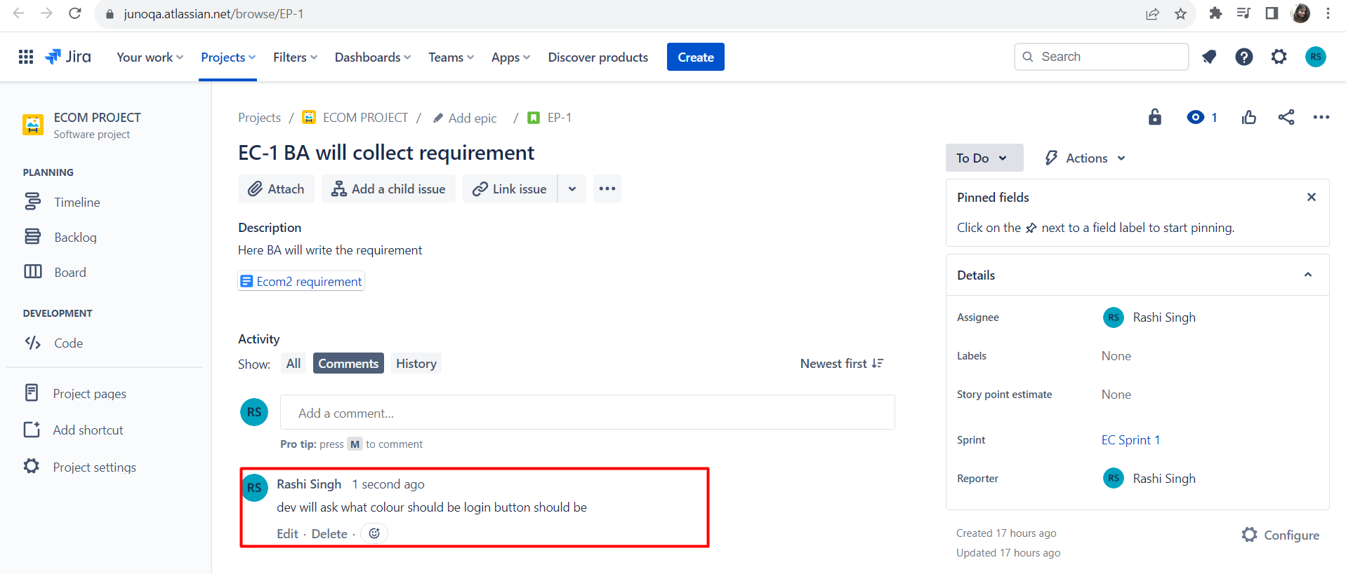

**Creating epic and adding summary**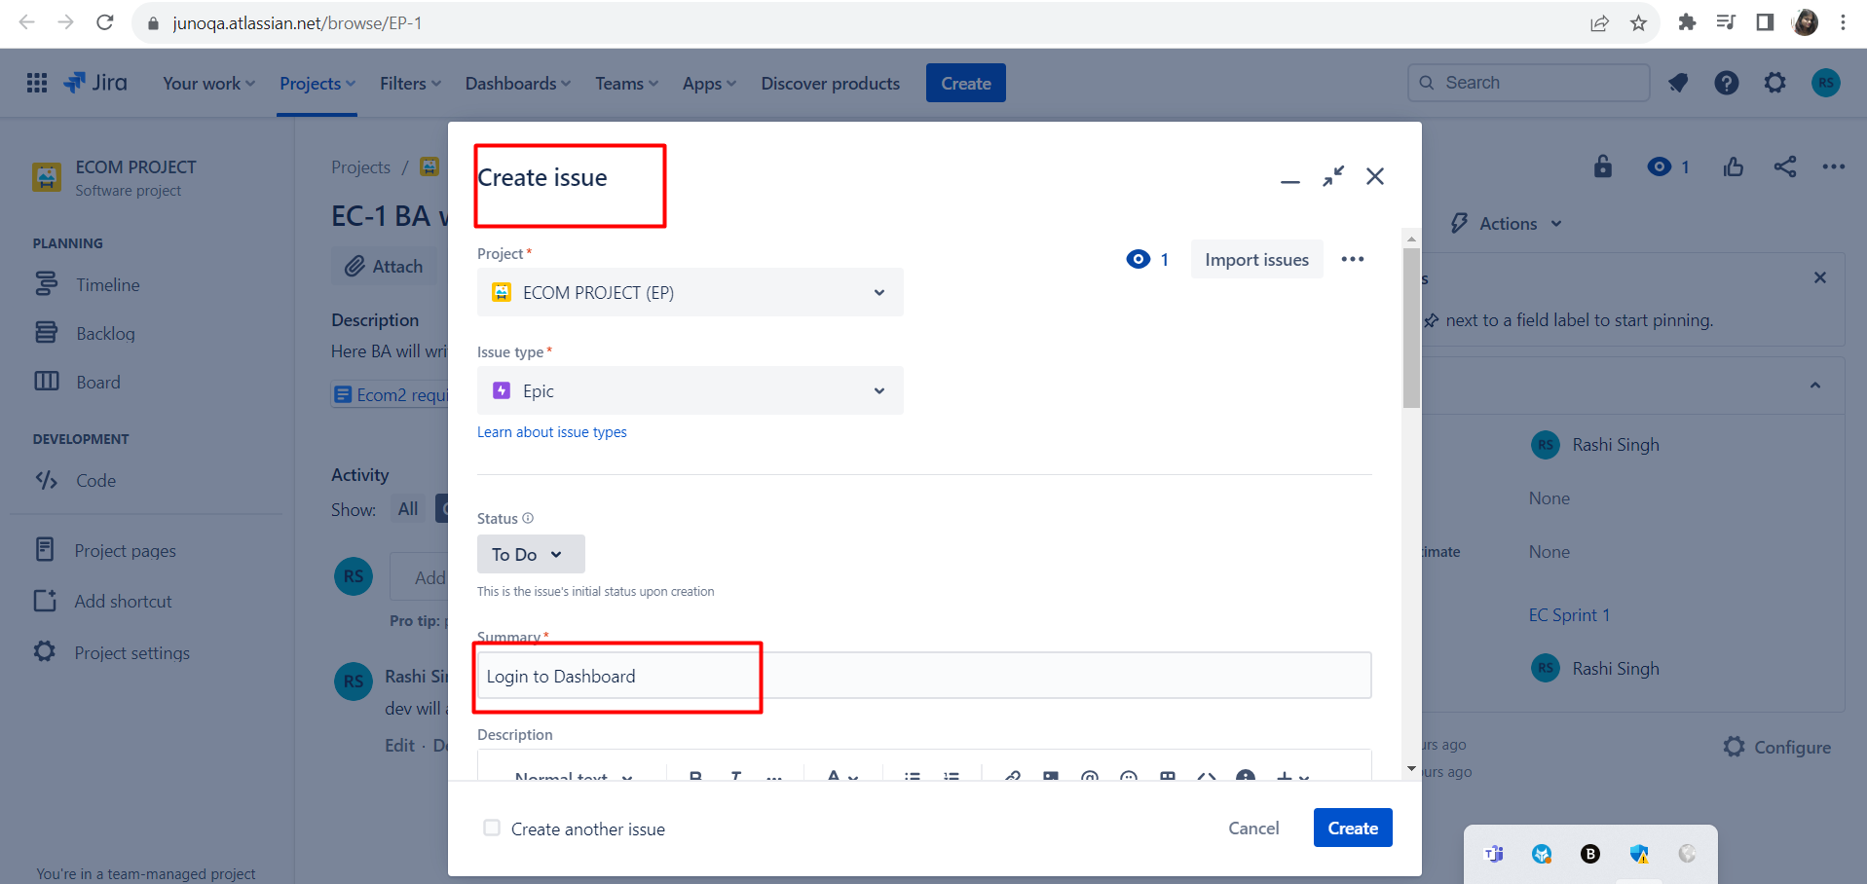

**Going to backlog and creating task for developer and adding stories**

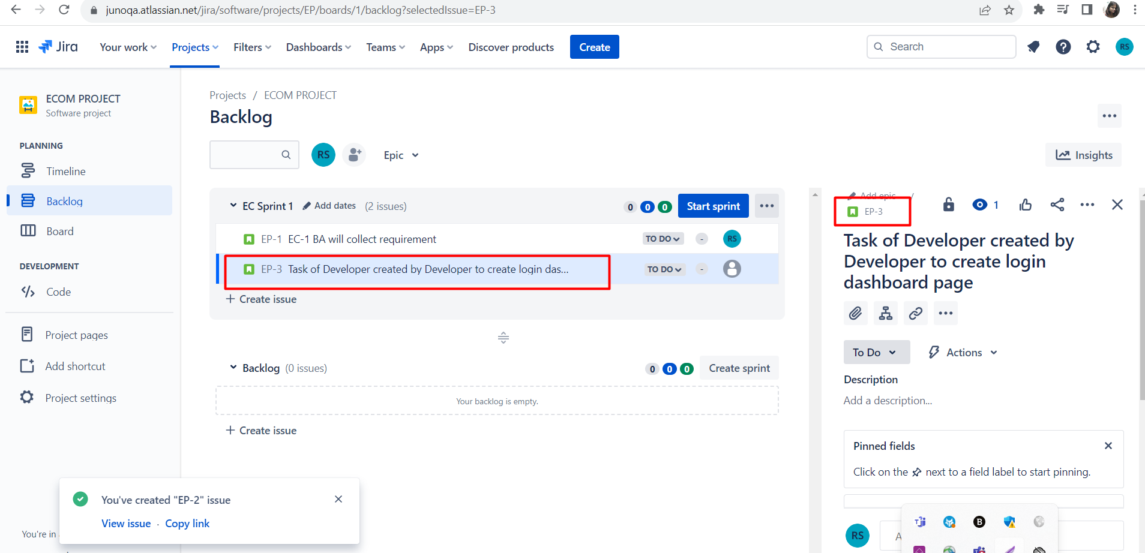

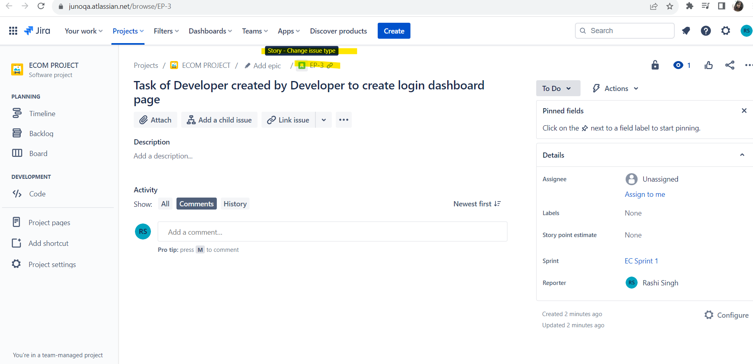

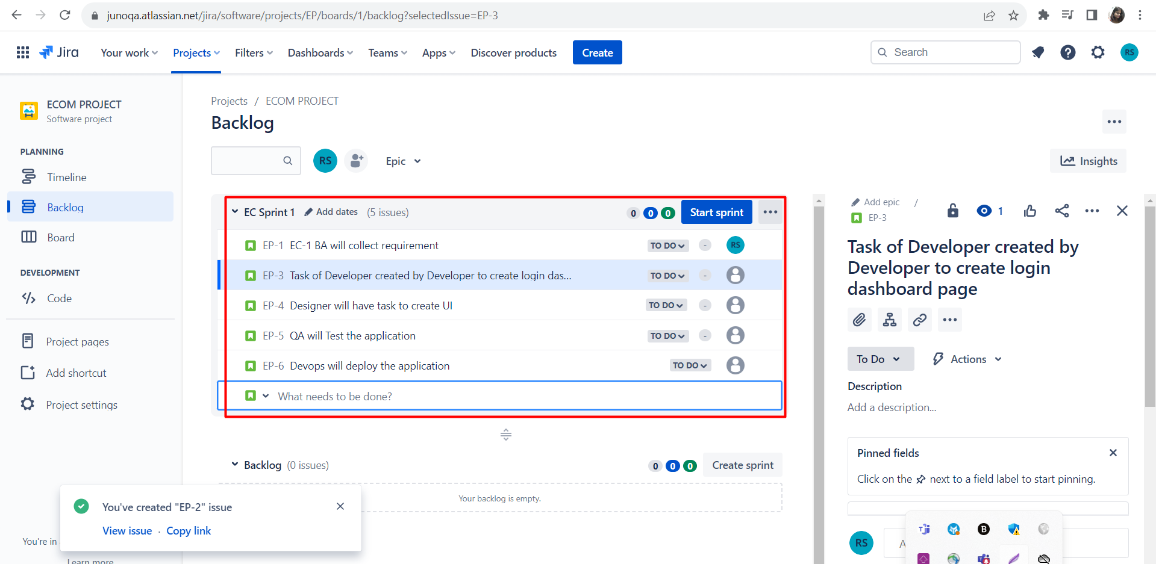

**

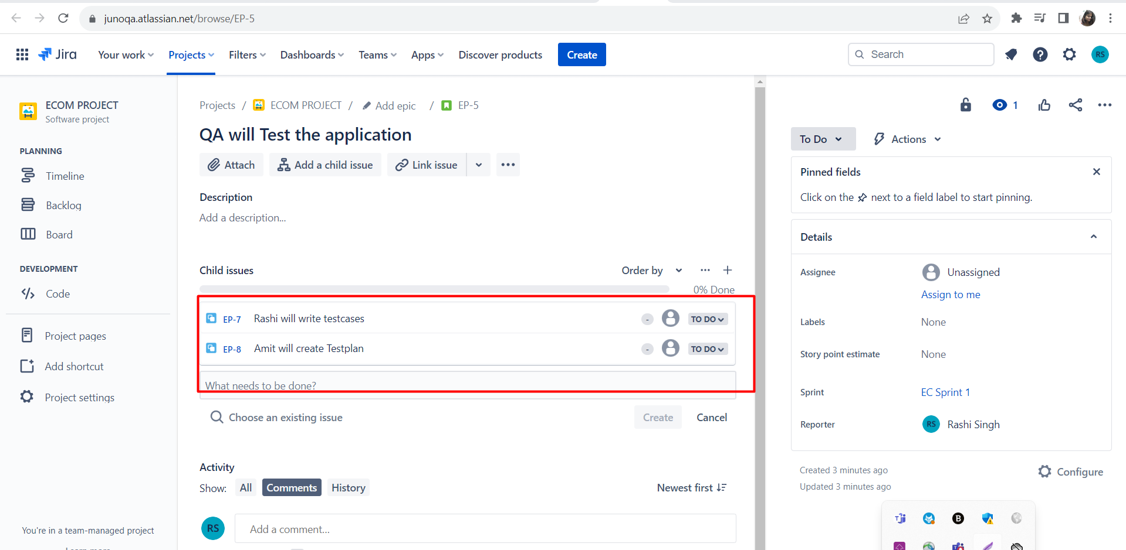

**

**And then add test plan in zephyr and approve the status**

**QA Roles starts in Zephyr scale**

**After test plan is approved you need to enter test cases**